CDIF, Croissant, and Semantic Croissant: How Do They Relate?
March 4, 2026 – Arofan Gregory, Slava Tykhonov, Simon Hodson

Overview
This document describes the relationship between the Cross-Domain Interoperability Framework (CDIF) and Croissant, and how these and other common Web standards and vocabularies are related. When it comes to FAIR resources such as research and statistical data and metadata, there are a number of different functions for which they are needed. Consequently, the range and expression of metadata required is extremely broad. Different formats are designed to support different functions, and the resulting picture can be confusing. This document explains at a general level how these different standards and formats work together to meet the range of different user needs.

High-Level Picture
The overall relationships of CDIF, the standards and vocabularies it uses, and Croissant are shown in the diagram below.
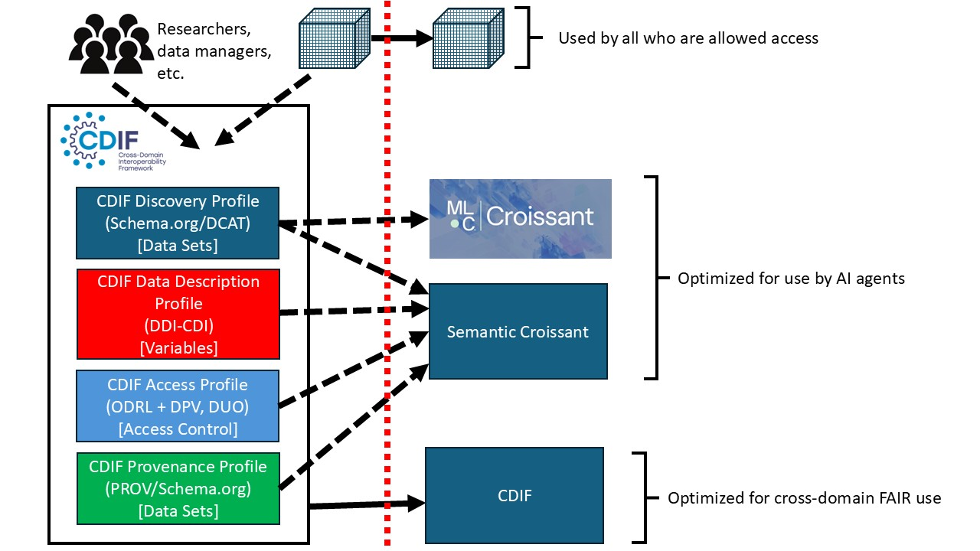
The red dotted line represents the activity of dissemination, through whatever systems are used: to the left of the line, resources are assumed to live in internal systems. To the right, they are exposed to qualified users.
Internally, we see the researchers, data producers, data managers, and others within the organization working with various systems to document their data holdings. Increasingly, such documentation will be the product of human-in-the-loop AI-driven systems, but whether produced in a more manual fashion or a more automated one is not material to the output produced. Here, a rich set of metadata is generated, meeting the minimum requirements for “cross-domain FAIR” established by the CDIF recommendations, and implemented in accordance with these. CDIF mandates that metadata be expressed as JSON-LD published in a standard fashion, so that it can be automatically consumed by users of any type, but including purely automated harvesters and AI agents.

CDIF
CDIF is intended to be a “hub format” or “lingua franca” – different types of users are expected to transform this core set of information into different standard expressions and formats which are meaningful within the user’s domain. CDIF is designed to sit between domains to support exchange, providing a rich set of metadata elements that can be used to provide generalized to granular description of resources at both structural and semantic levels, depending on the requirements of a community.
CDIF is not itself a standard: it is a set of guidelines for the use of existing “domain neutral” standards, with the inclusion of domain-specific semantic resources (such as ontologies, classifications, or other concept systems). Thus, the richness of domain semantics are not lost when the metadata is converted into a cross-domain form: they are merely referenced in a way which allows them to be identified and accessed. The semantics of CDIF itself are limited to those which are meaningful across domains, with the domain specifics still attached by not necessarily known to the end user, if they are coming from a different domain background.
CDIF provides a very detailed framework describing the component parts of data sets: variables. These variables may use domain-specific definitions, but non-domain users, including machines, will still be able to recognize and attach the relevant semantics even if they do not natively understand them. The structures are made reliably available for processing. This level of granularity is often missing from other standards – here, DDI-CDI is used to give a comprehensive description of variables to guarantee they can be fully processed by machines across many different “data set” contexts. (Note that the structural arrangement of data within a data set impacts how variable semantics are encoded – most data standards describe only a subset of possible combinations: DDI-CDI covers all of them by design.)
Externally, users will want to have different resources made available. Because CDIF relies on the use of existing specifications, some of which are quite common, some users – both human and machine – may want the CDIF expression of the metadata. A good example here is the use of Schema.org for a general description of a data set: this is immediately useful to harvesters which are indexing the available data, because it is a well-supported vocabulary. Other applications may understand PROV, for example, or DDI-CDI. In each of the functional areas covered, an appropriate standard – and sometimes two – is employed.
In the case of describing data sets for ML agents, CDIF is not the optimal form of metadata. Here, it is better to have Croissant, as this is a selection of the needed metadata specific for this purpose. Croissant 1.1 can largely be generated from the CDIF metadata, as both are similar in some important ways. Both, for example, use fields coming from Schema.org, and both are expressed using JSON-LD.

Semantic Croissant
Semantic Croissant is a version of Croissant which enhances the existing Croissant 1.1 fields with additional semantics drawn from the richer CDIF metadata set. This will specifically include information about variables and their representations within the data set, but could also extend to additional information about access, licensing, and provenance. Semantic Croissant has yet to be fully defined, but ideally will result from the partnership between the CDIF Working Group (convened by CODATA) and the ML Commons Croissant Working Group. There is already significant cross-membership, and some work on Semantic Croissant has already taken place within the ML Commons effort.
Like earlier versions of Croissant, existing vocabularies are used (notably Schema.org, but others as well). In many cases, the same set of eternal vocabularies are used within CDIF, and it is expected that Semantic Croissant would continue this pattern by directly employing fields from relevant external standards used now in CDIF. That said, the metadata in Croissant and Semantic Croissant is optimized for a different audience than CDIF is, so differences will exist.

Dataverse: An Illustrative Example
It is possible to use CDIF and Croissant with any dissemination system, but platforms such as Dataverse give us an excellent idea of what practical implementations will look like. When a dataset is checked into Dataverse for dissemination, a minimum set of metadata is added, and more is frequently mined, such that it is available for dissemination alongside the data. This includes Schema.org, Croissant 1.0, and DDI Codebook. In future releases, there are plans to extend this set to include DDI-CDI (the subset used in CDIF for data description) and Croissant 1.1. Ideally – given the existence of this metadata – it should be a simple matter to combine these into the publication of Semantic Croissant, although the fields concerning provenance and access will need to be considered. While these exist for CDIF, they are not currently supported by Dataverse.
The Dataverse repository does provide a good example for thinking about how this metadata will be practically exposed for use by ML agents, harvesters, and researchers in the real world.

